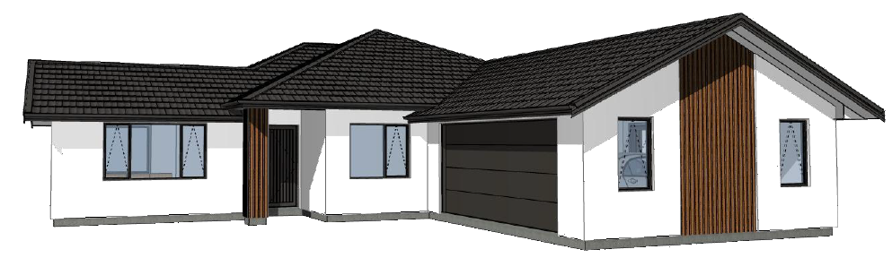  
  
  
Clients Name  
  
  
  
Schedule of Works & Materials

**SCHEDULE OF MATERIAL & WORKS**

|  |  |
| --- | --- |
| NEW HOMEOWNER: | Clients Name |
| JOB NUMBER: | JNB000 |
| SITE ADDRESS: | 123 Berryfield Lane, The Meadows, Richmond – Lot 123 |
| DATE: | 20-Jan-21 |
| HOUSE TYPE: | DESIGN/BUILD |

|  |  |  |
| --- | --- | --- |
| RETAIL PRICE: | $462,765.45 | (Including GST) |
| CONTRACT PRICE: | $455,756.21 | (Including GST) |
| LESS DEPOSIT: | $5,000.00 | (Including GST) |
| BALANCE: | $443,716.34 | (Including GST) |

|  |  |
| --- | --- |
| GROUND FLOOR AREA (GFA): | 190.97m2 |
| HOME CONSULTANT: | Ryan Beattie |

# CLIENT APPROVAL

1. Before you read this contract, it is important that you understand that this document is the basis for building your new home. All previous discussions that you have had with the consultant about various products etc. are now irrelevant as this document represents what you have finally agreed on
2. To ensure that you acknowledge all the aspects of this schedule, we will tick each clause upon your confirmation that you fully understand and for any reason you do not – please ask your consultant to explain

# CONTRACT NAMES

1. It is important that this Building Contract is in the same name as the title of your section or property. Councils will only accept a Building Consent Application where the name on the application matches the Title, if you are considering changing your section purchase name to the likes of a Trust please notify your Home Consultant of this change

# CERTIFICATE OF TITLE

1. If a certificate of title has not been issued at the time of the dated signing of this contract then no allowance has been made for the financial outcomes of any of the Consent Notices that may be attached to the Certificate of Title. A variation may have to be presented after the dated signing of the contract upon final sighting of the said Consent Notices (if any)

# PRELIMINARY AND GENERAL

1. This schedule of materials and works shall be read in conjunction with the plans, but where any ambiguity occurs, the schedule shall take precedence
2. All work is to be completed in accordance with the schedule of material and works best industry practice, including the NZ Building Code, and the relevant acceptable solutions. Additional costs incurred because of changes in the building code or conditions over the contract period will be charged to the owner
3. The pictures shown in this schedule are an example only to give an indication of product and the wording is to take precedence over any of the pictures
4. It is the client’s responsibility to highlight all covenants etc
5. Registered Master Builders 10-year guarantee included
6. Includes full working drawings
7. Includes a Provisional Sum of **$7,377.51** for the building consent fees, BRANZ levy and the department of building housing levy
8. Development contribution levy & service connection fees by Tasman District Council are not included
9. Does not include the service connection fee for storm water and sewer charge by the Tasman District Council
10. Includes the Network Tasman new load policy fee, this will be included as part of your electrical
11. Includes a Provisional Sum of **$1,300** for Resource consent fees due to breach of side boundary
12. Maintenance period shall be 3 years from possession date
13. From accepting and signing a variation to the contract, an invoice shall be created. All payments of variations are due within seven (7) working days of the date the invoice is issued. If there is a delay in payment this could result in a delay of your build
14. Builders ‘All Risk’ & Liability insurance cover whilst under construction for goods and services by Jennian Homes only.
15. Jennian Homes have an active Health & Safety Policy in place and is committed to this policy
16. If owners require any extra work, the builder’s labour rate will be charged out at **$90.00** per hour
17. If owners require any Draughting and Architectural extra’s or variations these will be charged out at an hourly rate of $100 per hour
18. For any variation that may occur to the contract price Jennian Homes will notify our client at the earliest possible stage
19. House professionally cleaned internally windows internally and externally to the completed home.
20. Removal of all rubbish (skip on site)
21. No allowance has been made for additional works i.e. retaining walls or fences to any internal boundaries due to siteworks performed on adjacent sections that could possibly undermine ground levels
22. No allowance has been made for any alterations to the street crossing. Jennian Homes will inspect the existing footpath, kerb and crossing prior to the works beginning and will notify the owner of any damage. Jennian Homes will ensure that all their contractors use the dedicated vehicle crossing, however if this crossing becomes damaged Jennian Homes will not be responsible to rectify the damage
23. All costs shown **include GST**

# OWNERS CARE INSURANCE

1. There is no Owners Care in this contract

# ENGINEERING

1. This project has a RibRaft floor which will need to be inspected and passed by a Structural Engineer, the Engineers professional fees for these inspections has been included in this schedule
2. Apart from the RibRaft floor this project has no requirement for an Engineer to be involved; however through the discovery of poor bearing ground during the excavation it may become necessary to engage an engineer for a specific foundation design involving additional costs
3. No allowance has been made for a Geotechnical Engineer

# TEMPORARY POWER & MAINS POWER SUPPLY

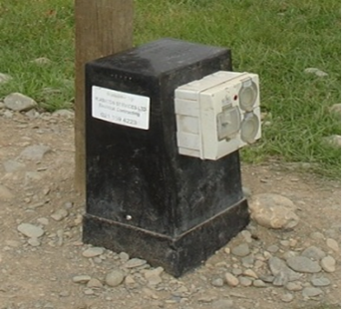

Temporary Power Box

1. This contract makes provision for a temporary power supply from the on-site black box
2. Includes the supply and laying of a maximum of 20.0m of underground power and telephone cable with connection to the onsite power box and connection fees

# EXCAVATION

1. This contract makes provision for the excavation of the area to be covered by the building floor slab including an area extending up to 1.0m beyond the floor slab perimeter
2. Allowance has been made for this area to be excavated to a maximum depth of 300mm below natural ground level; then filled to a depth of 250mm of compacted hard fill and sand blinding. However, if this excavation depth is exceeded to obtain solid bearing this would become an extra to the contract price and would be treated as a variation to the contract
3. All topsoil shall be stripped from the area to be covered by the building and **top soil stockpiled on-site,** bulk excavation removed from site.
4. Includes the excavation and removal of spoil up to **93.00m3**
5. Includes the supply and compaction of hardfill up to **70.00m3**
6. If additional quantities are required to provide a level platform, due to soft soil, height requirements, etc. these will be charged as a ‘Variation to Contract’

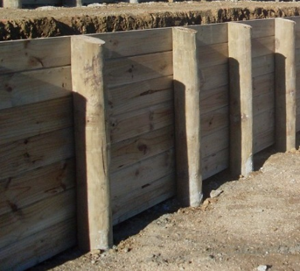

Retaining Wall

# RETAINING WALLS

1. No allowance has been made for any form of timber retaining wall

# FLOOR SYSTEM

1. This contract allows for a Firth RibRaft floor system

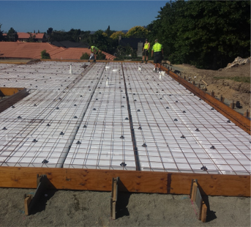

RibRaft Floor System

1. This is a reinforced concrete waffle raft floor slab consisting of a grid of polystyrene pods to form a reinforced concrete floor slab
2. The perimeter edge of the foundation will be boxed and left fairface finish not plastered or painted
3. Floor Slab will be 85mm thick concrete reinforced with 615-500E ductile mesh

# FRAMING

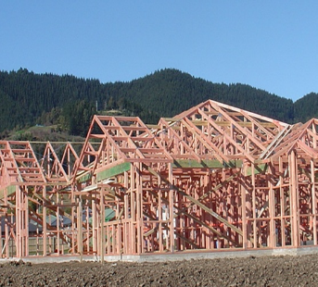

Timber Framing

1. All timber frames shall be Radiata kiln dried 90 x 45 H1.2 treated timber
2. Trusses shall be Radiata Pine kiln dried gang nail with a 25-degree pitch
3. Includes timber framed columns to entry

# ROOF, FASCIA, GUTTER & DOWNPIPES

1. Roofing shall be Gerard Stratos *(Corona Shake)* Satin with angle trim Roofing tiles installed by a Gerard Certified Roofer
2. Gerard roofing comes complete with a 50 year guarantee
3. Fascia and gutter shall be Freeline fascia and quad gutter system
4. Downpipes shall be 80mm PVC round profile Marley coloured

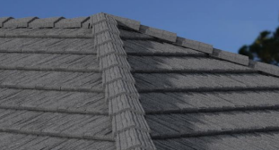

Gerard Stratos tiled roof

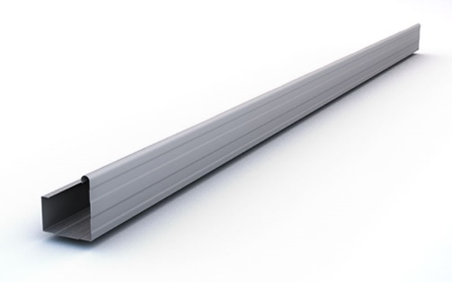

Freeline Square Fascia/Gutter

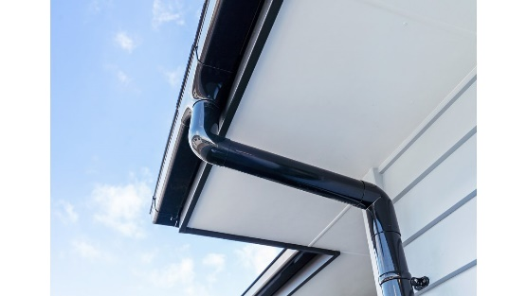

80mm Round Marley painted downpipe

# SOFFITS

1. Shall be horizontal, and lined with Hardies Hardiflex

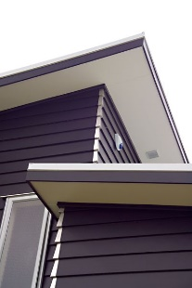

Hardiflex Soffit

1. Includes PVC jointers

# CLADDING

1. Shall be a combination of Resene Rockcote 50mm insulated panel system complete with graphex rendered plaster and Vertical Cedar on a 50x25mm cavity batten system and schist stone
2. Gables to be clad as per plans

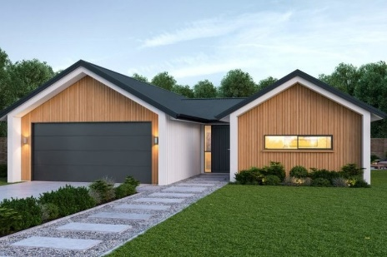

Vertical Shiplap Cedar

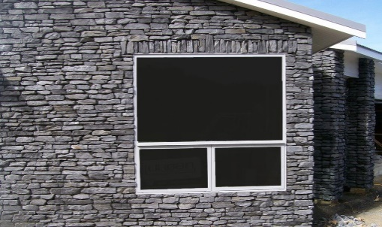

Schist Stone

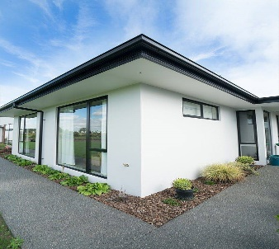

Resene Rockcote Rendered Plaster

# ALUMINIUM JOINERY, ENTRANCE & GARAGE DOOR

1. All aluminium window joinery shall be the Altherm Residential Suite
2. Windows and doors in the living areas to be clear double glazed
3. Windows and door in the garage to be clear double glazed
4. Powder-coated aluminium windows and doors as per plan
5. Opalite glazing to the bathroom, ensuite and WC
6. Window hardware to be colour matched Urbo
7. Window reveals to 19mm thick, pine paint grade
8. Including venting catches to all windows excluding slider windows
9. Door sills to be flush with floor coverings. (Rebated into the floor slab)
10. Entry door to be a Latitude vertical TG&V aluminium entrance door set in an aluminium frame
11. Entry door shall be fitted with a Windsor 7099 pull handle with lock set
12. Garage door to be a Futura sectional, fully insulated door with an internal auto opener, two remotes
13. Garage door openers to be wireless
14. Garage door reveals to be paint grade

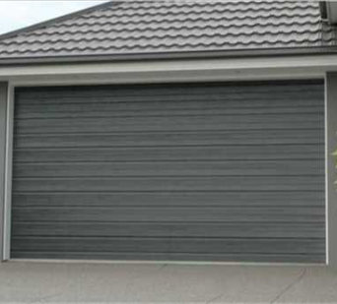

Futura Sectional Garage Door

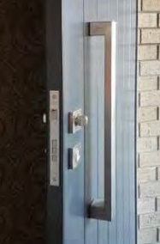

Polo Pull 7099 entrance set

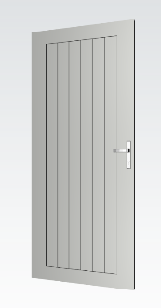

Latitude Vertical Entry Door

# SKYLIGHTS, ROOFLIGHTS AND SOLARTUBES

1. No allowance has been made for a solar tube, skylight or rooflight

# THERMAL INSULATION

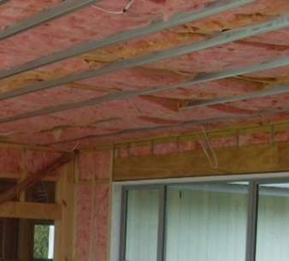

Ceiling Insulation

1. Pink Batts to the ceiling of the home shall be R3.6
2. Pink Batts to all outer walls of the home shall be R2.6
3. No insulation shall be fitted to the external walls and ceiling of the garage, but will be fitted to the internal wall between garage and house

# INTERIOR LININGS

1. Rondo steel ceiling batten system fitted to Rondo expansion clips to minimize any screw popping
2. Ceilings shall be lined with 13mm GIB
3. Walls shall be lined horizontally with 10mm GIB
4. Aqualine GIB to walls and ceilings of the bathroom and ensuite
5. All walls and ceilings to be stopped to a level 4 finish
6. All 90-degree external corners shall be square stopped



Rondo Steel Ceiling System



Square Stopped Corners

# CEILING HEIGHTS / FEATURES / BULKHEADS

1. Entry, Kitchen, Dining and Bed 4 shall have 2.7m high flat ceilings the remainder to be 2.4m high
2. Bulkhead included over the kitchen

# SKIRTING, SCOTIA, ARCHITRAVE

1. Skirting shall be 60mm x 12mm MDF bevel edge with the same profile in pine to the wet areas
2. Architrave shall be 60mm x 12mm MDF bevel edge with the same profile in pine to the wet areas
3. Scotia shall be 55mm GIB coving fitted to the wall/ceiling junction in the 2.4-metre-high ceiling areas
4. Scotia shall be MDF bevelled cornice to the wall/ceiling junction in wardrobes and cupboards

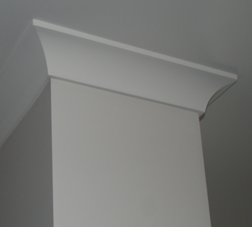

GIB Coving

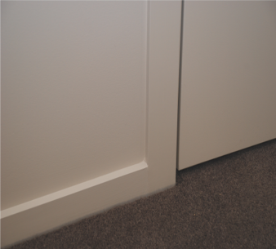

Bevel Edge Skirting

# INTERIOR DOORS & HARDWARE

1. All doors shall be hollow core MDF flush panel paint grade 1980mm high
2. Door jambs shall be HAG 11 paint grade
3. Door jambs shall be pine clears paint grade to the ensuite and bathroom
4. All the interior door handles shall be Windsor Corbel lever handles
5. Windsor 9034 privacy locks will be fitted to the WC, ensuite and bathroom only
6. Skirting mounted Windsor 5240 door stops to all doors
7. Brushed Nickel finish

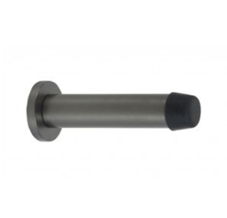

Windsor Door Stop

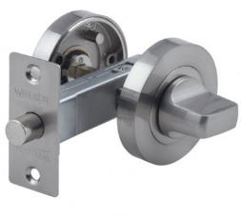

Windsor Privacy Lock

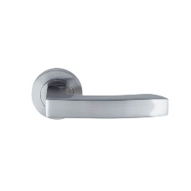

Windsor Corbel Lever Handles



Hag 11 Door

# WARDROBES

**All storage systems by Re-Space**

1. Wardrobe joinery (value $2,524.25)
2. Master bedroom – Melamine shelves, full and double hang walk in wardrobe system 1800mm x 1620mm
3. Bedroom 2 & 3 – Melamine single shelf and pole system 1900mm
4. Bedroom 4 – Melamine single shelf and pole system 1400mm
5. Laundry – Melamine set of four shelves 900mm wide x 450mm deep

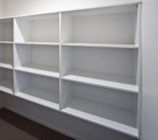

Melamine Set of Four Shelves

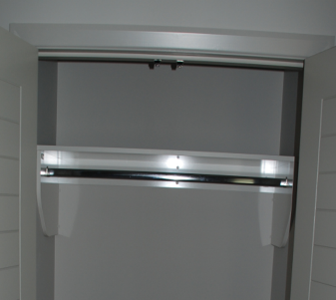

Shelf and Pole System

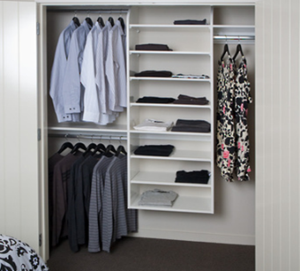

Shelves, Full & Double Hang

# ROOF ACCESS & ATTIC STORAGE

1. Shall include a standard ceiling access panel located in the garage to provide access to the roof space
2. No allowance has been made for an attic storage space

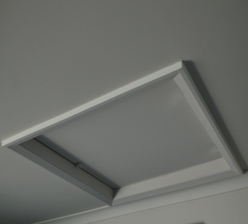

Ceiling Access

# KITCHEN & PANTRY JOINERY

1. 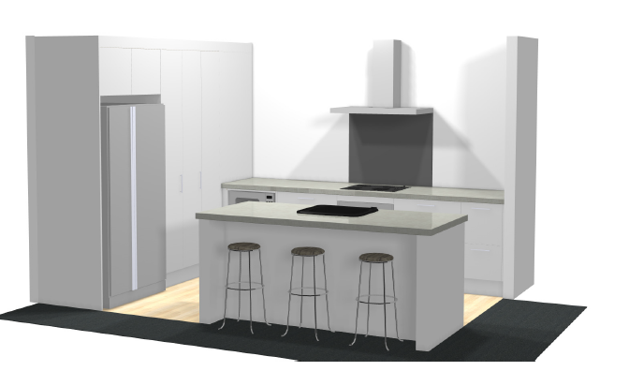Kitchen Joinery provided by Trends as per quote KIT_47152 (Provisional Sum $19,422.00) including full width splash back

# APPLIANCES

**All appliances Fisher and Paykel stainless steel finish**

1. Oven – F & P Pyrolytic Wall Oven OB60SC7CEPX1
2. Cooktop ­– F & P Induction Cooktop CI604CTB1
3. Rangehood ­– F & P Designer Rangehood HC90DCXB3
4. Dishwasher – F & P Dishwasher DW60FC6X1
5. Canopy rangehood to be vented to the exterior through the soffit

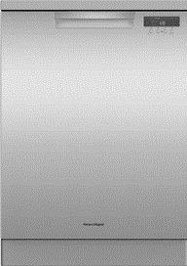

F & P Dishwasher DW60FC6X1

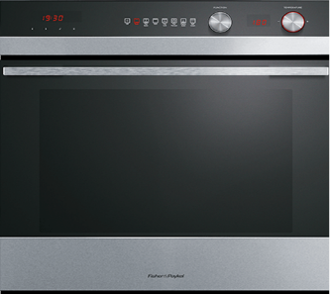

F & P Pyrolytic Wall Oven OB60SC7CEPX1

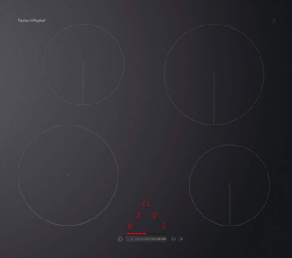

F & P Induction Cooktop CI604CTB1

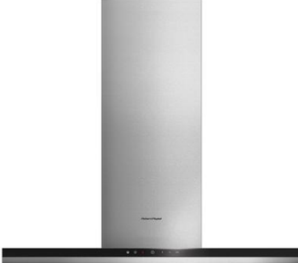

F & P Designer Rangehood HC90DCXB3

# ELECTRICAL

|  |  |  |  |
| --- | --- | --- | --- |
| Hot Points (all RCD protected) |  | Lighting |  |
| Garage door single power point | 1 | 5ft LED Battens LED442N | 2 |
| Electric water heating point | 1 | Recessed Downlight E-Lightz | 32 |
| Double power point with USB | 4 | Dimmer Switch | 3 |
| Double power point | 32 | Two-way switches | 6 |
|  |  | Three-way switches | 4 |
|  |  | Pendant Lights (Prime Cost Sum $200 each) | 3 |
| Appliance Points |  | Fixtures |  |
| Microwave | 1 | 7 Rung towel rail | 2 |
| Fridge | 1 | 150mm in-line extraction fan | 2 |
| Dishwasher | 1 | Cavius Miniature Smoke Alarm | 2 |
| Rangehood | 1 | Broadway Mirror | 2 |
| Wall oven | 1 | Bathroom Heater | 2 |
| Electric hob | 1 |  |  |
|  |  |  |  |
| Media / Communication |  | Ventilation |  |
| Double data point | 4 | Smart Ventilation System as per The Meadows Subdivision Resource Consent | 1 |
| Primary T.V. point | 1 |  |  |
| Secondary T.V. point | 1 |  |  |
| Audio visual communications hub | 1 |  |  |

# BATHROOM

|  |  |
| --- | --- |
| Shower | 1000mm x 1000mm Athena Soul white angle corner moulded wall shower unit |
| Vanity | 900mm Athena Norfolk Classic wall hung cabinet with composite top |
| Bath | Athena Contro Back to Wall 1600 x 750 |
| Shower Mixer | Elementi Ion |
| Shower Slide | Splash three function |
| Basin Mixer | Elementi Ion |
| Bath Mixer | Elementi Ion |
| Bath Spout | Methven Aio wall mounted |

# WC

|  |  |
| --- | --- |
| Toilet | Elementi Uno BTW toilet suite, square cistern and soft close seat |
| Toilet Roll Holder | Alexander Tetris |

# ENSUITE

|  |  |
| --- | --- |
| Shower | 1000mm x 1000mm Athena Soul white round corner moulded wall shower unit |
| Vanity | 1200mm Athena Norfolk Classic wall hung cabinet with composite top |
| Toilet | Elementi Uno BTW toilet suite, square cistern and soft close seat |
| Toilet Roll Holder | Alexander Tetris |
| Shower Mixer | Elementi Ion |
| Shower Slide | Splash three function |
| Basin Mixer | Elementi Ion |

# LAUNDRY

|  |  |
| --- | --- |
| Tub | Aquatica Laundra Tubbie |

# KITCHEN

|  |  |
| --- | --- |
| Sink | Elementi Uno Gooseneck |

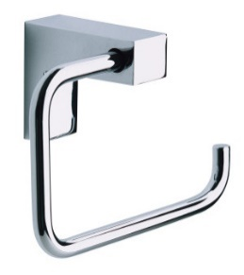

Alexander Tetris Toilet Roll Holder

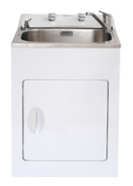

Aquatica Laundra Tubbie

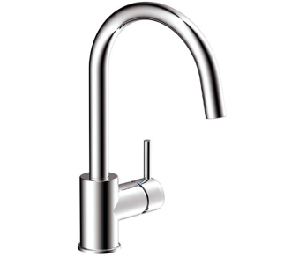

Elementi Uno Kitchen Mixer

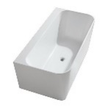

Contro BTW Bath

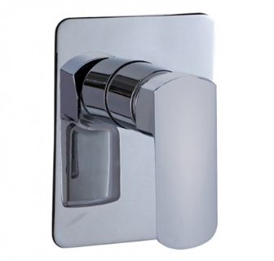

Elementi Ion



Ion Basin Mixer



Splash Shower Slide & Head

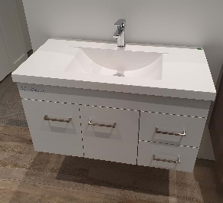

Norfolk Wall Hung Vanity

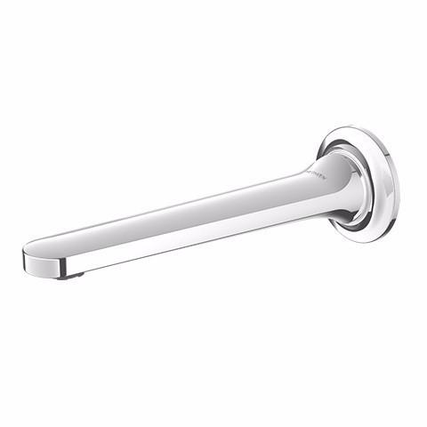

Aio Bath Spout

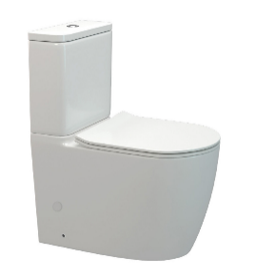

Elementi Uno Toilet Suite

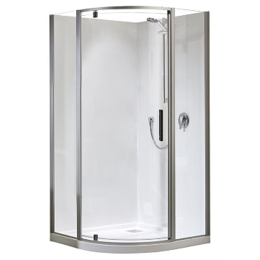

Athena Soul Round

Shower

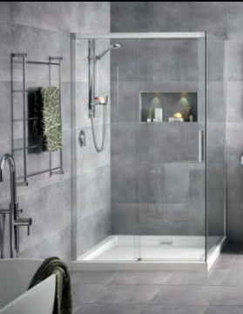

Motio Tiled Shower

# PLUMBING

1. Shall include the complete internal plumbing of hot and cold water via **Fusiotherm** pipework
2. Shall include a 250 Litre, Mains Pressure, Enamel, Rheem Hot Water Cylinder

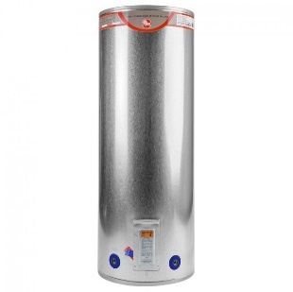

250 Litre Rheem HWC

1. Allowance has been made for **3** external hose taps located outside garage, living and ensuite
2. Includes pop up wastes to all vanity basins and the bath

# FRIDGE WATER SUPPLY

1. No allowance has been made for a fridge water connection

# DRAINAGE

1. Includes sewer/stormwater drains, sumps and gullys finished to correct council levels. Should your landscaping affect these finished heights then any rectification work required will be at your own cost
2. All drains, phone, power and water to house. Owners to connect and transfer power and phone account
3. Includes a 300 x 300 surface water sump to the driveway and another one to the patio

# GAS INSTALLATION

1. No allowance has been made for gas appliances and/or heating

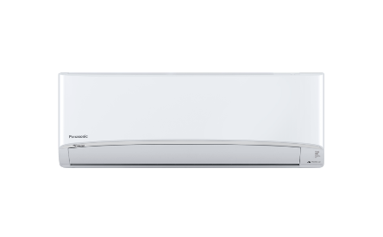

Panasonic CS/CU RZ42WKR

# HEATING

1. Shall include a high wall Panasonic CS/CU-RZ42WKR inverter heatpump
2. Interior heat pump unit shall be located in the dining room

# SOLAR

1. No allowance has been made for any solar

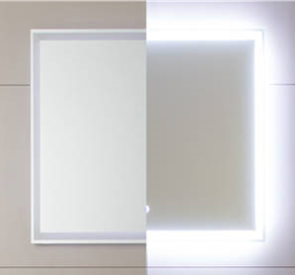

Broadway Mirror

# MIRRORS

1. Shall include two 900 wide Broadway mirror fixed above each of the vanities

# DECORATING

1. Resene paint system to the complete home
2. Ceilings to be Resene flat ceiling paint
3. Interior walls to be Zylone sheen 3 coat system
4. All interior wall and ceiling colours to be from a white base
5. Limited to two wall colours throughout
6. Dark base colours, feature walls and picking out skirtings is all an extra
7. Lustacryl semigloss to bathroom ensuite walls and ceiling’s
8. Enamel to all interior doors, skirtings, architraves, window and door reveals
9. Wall colours will extend around into the back edge of all window and door architraves
10. Exterior painting/stain shall include the soffits, weatherboards and garage door jambs
11. Downpipes shall be Marley coloured
12. Plaster finish will be painted under the work of the Rockcote Contractor

# COLOUR SCHEMES

1. Shall include the services of a professional colour consultant at Studio J
2. Choice of colours for the various products included in this contract will be from the manufacturers standard colour range

# DRAPES

1. No allowance has been made for drapes or blinds

# CARPET

1. This contract includes a **Provisional Sum of $8,725.00** for carpet
2. All carpet from Hubbers Flooring as per quote

# VINYL

1. This contract includes a **Provisional Sum of $2,665.00** for vinyl
2. All vinyl flooring from Hubbers Flooring as per quote

# TILING

1. No allowance for any tiling

# DRIVEWAYS & LANDSCAPING

1. Includes **77.06m2** of exposed aggregate including reinforcing mesh

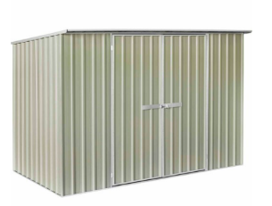

Garden Shed

1. Includes **19.45m2** of plain finished patio including reinforcing mesh
2. Includes 3000 x 2500 =**7.74m2** of plain finished concrete pad to garden shed including reinforcing mesh
3. This contract allows for a Number 8 Garden Shed 3000 x 1500

# DECKS

1. No allowance has been made for the building of a pergola

/

a) No allowance has been made for any form of timber decking

# PERGOLAS

1. No allowance has been made for the building of a pergola

# WARRANTIES

1. To ensure that all guarantees and warranties for the product included in this project remain valid, please keep up with the recommended maintenance programme

# MAINTENANCE

1. After taking possession the maintenance period will be 3 years
2. 90 days after the possession date, our construction manager will make contact to arrange a home visit. Prior to this visit if you could take note of any maintenance that may need attending.
3. For any urgent matters please contact our Construction Manager
4. This maintenance period is non-transferable and only remains valid as long as the owner of the home is the person stated at the top of this schedule of works

# EXCLUSIONS

1. Valuation fees
2. Surveyor’s fees for lost boundary peg locations
3. Letterbox, clothesline, or television aerial
4. Water rates used during build (to be by owner)
5. Sealing of exposed aggregate driveway
6. Floor coverings

# PRODUCT OPTIONS

1. None

# SUMMARY OF PROVISIONAL SUMS INCLUDED IN THIS CONTRACT

Provisional sums are an estimate for portion of work, for example site excavation - for which the extent is not known. Accordingly, the amount of a provisional sum can be, to a large extent, outside of either party’s control.

1. Building Consent $7,377.51
2. Resource Consent $1,300.00
3. Drainage $6,325.00

# SUMMARY OF PRIME COST SUMS INCLUDED IN THIS CONTRACT

Prime cost sums cover the supply cost only for a specific item; example a bathroom vanity, a PC sum is to be spent at the instruction of the client, meaning they will have some ability to control the final amount

1. None

# CONFIRMATION OF PLANS

1. Final plans need to be checked carefully, as with the new Building Act alterations cannot be made after the submission of the documents to the council
2. If an amendment were to be made, no further work at that stage could proceed until it has been approved by the Council
3. This would affect construction time and possession dates
4. Clients will incur a fee from not only the Council but Jennian Homes for this amendment

# VARIATIONS TO CONTRACT

1. Once the plans are finalised and the Contract has been signed, all changes will be made by a ’Variation to the Contract’. If there has been a change made after the Contract this will be in a written format and will need to be signed off for the change of works to take place
2. There will be two copies of the V.O., one for the owner and one to be signed and returned to the Jennian Office
3. *Note:* If you do not have the ‘Variation of the Contract’ signed and returned to the office the current contract will still stand. A verbal agreement with a member of the Jennian Office will not be considered a ‘Variation to the Contract’

# EXPECTED START DATE

1. Please read the following in reference to ‘Part 3 - Specific Conditions’ No’s III and IV of the attached Masterbuild Contract
2. It is a requirement to provide specific dates for expected start and completion dates as part of the contract. These dates are a guide only and are subject to change
3. Jennian Homes will do their upmost best to achieve the earliest outcome possible, however it is important to be aware that much of this process is out of our hands, such as the following:
   1. Engineering requirements are dealt with from outside our office and processing times can vary depending on their nature
   2. Resource Consents can take longer than Building Consents and can hold up the Building consent issue
   3. Building Consents can be held up by the Local Territorial Authority in general, for multiple reasons at their own discretion
4. If a title for a section has not yet been issued at time of Contract, the development of these sections falls under the same scrutiny as mentioned in clause (c)
5. Jennian Homes would recommend working on a start date within 6 weeks of the Building Consent being applied for, and/or the completion date being within 24 weeks of the actual start date

# CLIENT APPROVAL

Signed by Client: Date:

Witnessed by Jennian Homes Date: